TOPIC 4 — DYNAMIC PROGRAMMING

Q1. Dice Throw Problem

Aim:
To find number of ways to reach a target sum using dynamic programming.

Algorithm:

- Read num_sides, num_dice, target.
- Initialize DP table.
- Fill using recurrence: dp[d][t] += dp[d−1][t−i].
- Return dp[num_dice][target].
- Output total ways.

Code:
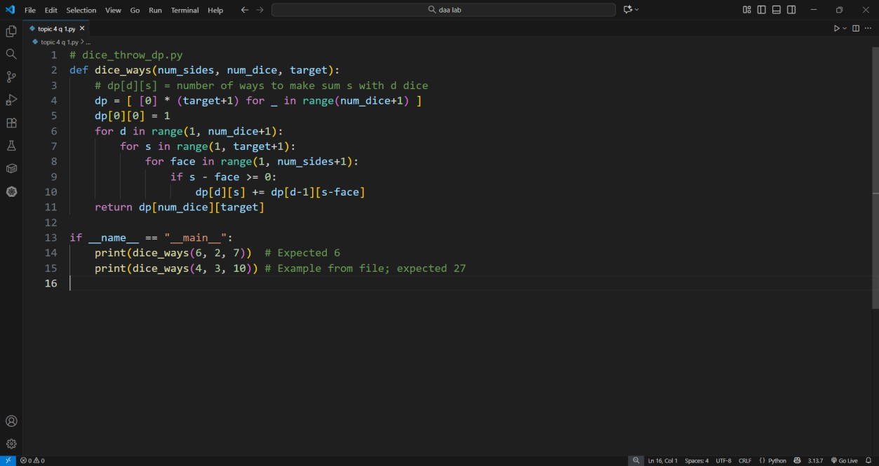
Input: num_sides=6, num_dice=2, target=7

Output:
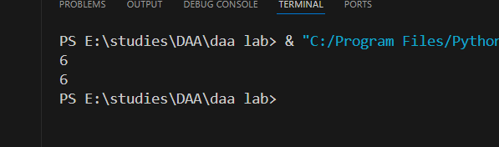

Result: Correct number of dice combinations calculated.

Q2. Longest Palindromic Substring

Aim:
To find the longest palindrome within a given string using DP.

Algorithm:

- Initialize DP table for substrings.
- Mark single letters as palindrome.
- Expand substrings outward.
- Update max length when palindrome found.
- Return substring.
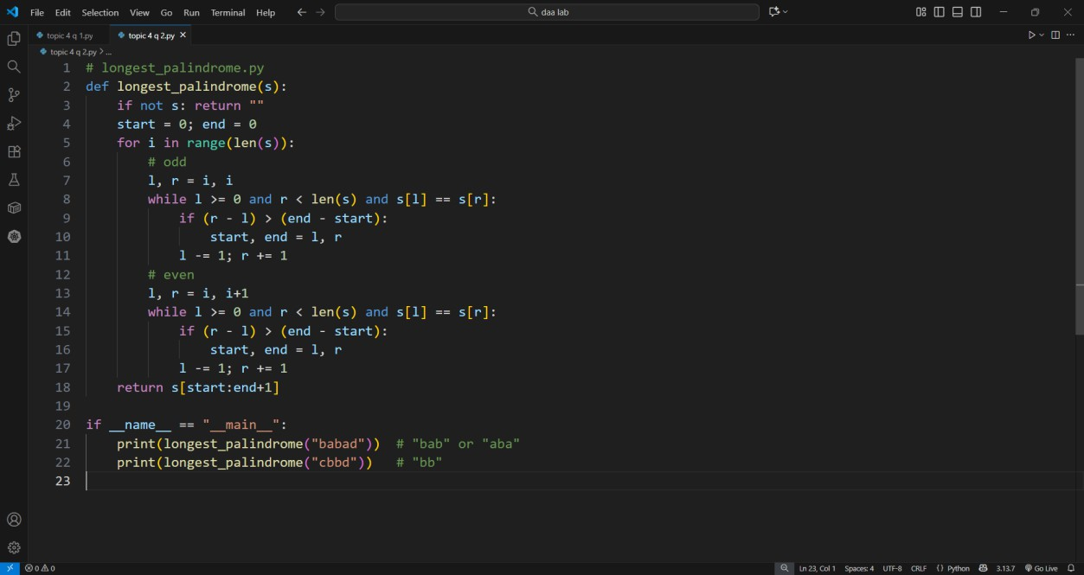

Input: "babad"

Output: "bab"
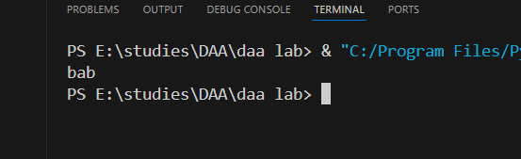

Result: Longest palindrome identified correctly.

Q3. Word Break Problem

Aim:
To check if a string can be segmented into valid dictionary words.

Algorithm:

- Read input string and dictionary.
- Create DP array dp[n+1].
- Initialize dp[0]=true.
- For each index, check substrings in dictionary.
- Return dp[n].
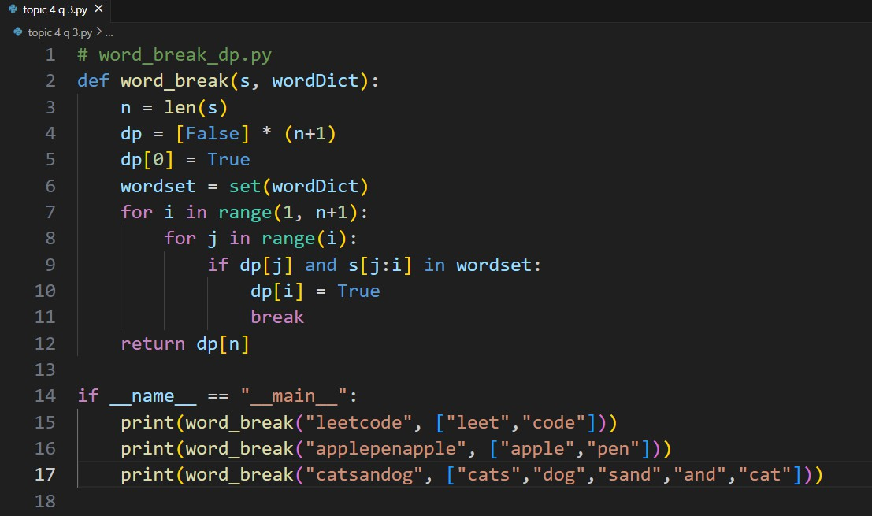
Input: "leetcode", ["leet","code"]

Output:
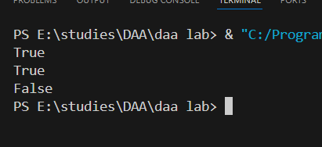

Result: String segmented successfully.

Q4. Floyd-Warshall Algorithm

Aim:
To find shortest paths between all pairs of vertices.

Algorithm:

- Input weighted adjacency matrix.
- For k = 1 to n:
  - For each i, j update: dist[i][j]=min(dist[i][j], dist[i][k]+dist[k][j]).
- Repeat for all vertices.
- Print final matrix.
- Display shortest paths.

Code:
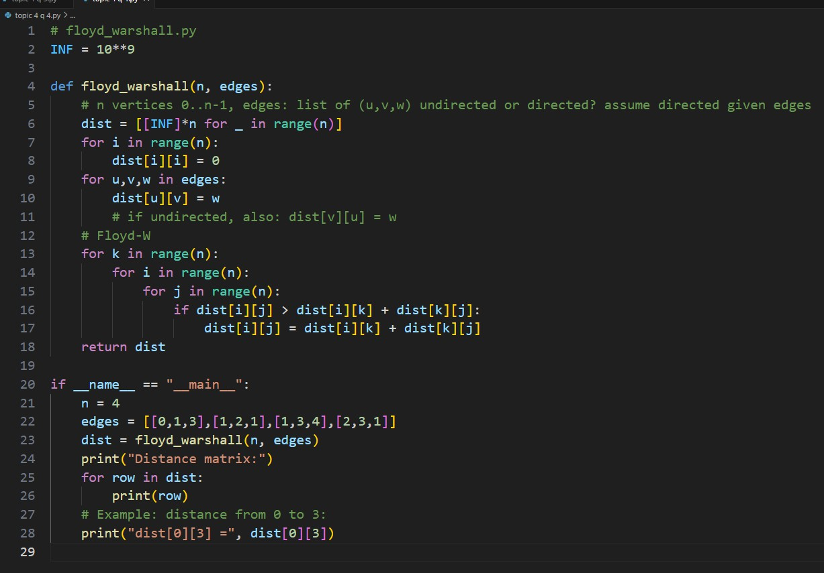
Input: Distance matrix of 4 cities.

Output: Updated shortest path matrix.
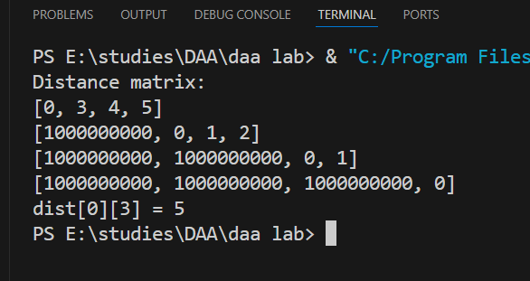
Result: Shortest paths correctly computed.

Q5. Optimal Binary Search Tree

Aim:
To construct a binary search tree minimizing expected search cost.

Algorithm:

- Input keys and frequencies.
- Initialize cost matrix.
- Compute cumulative frequency.
- Apply DP to fill cost[i][j].
- Display minimum cost and root matrix.

Code:
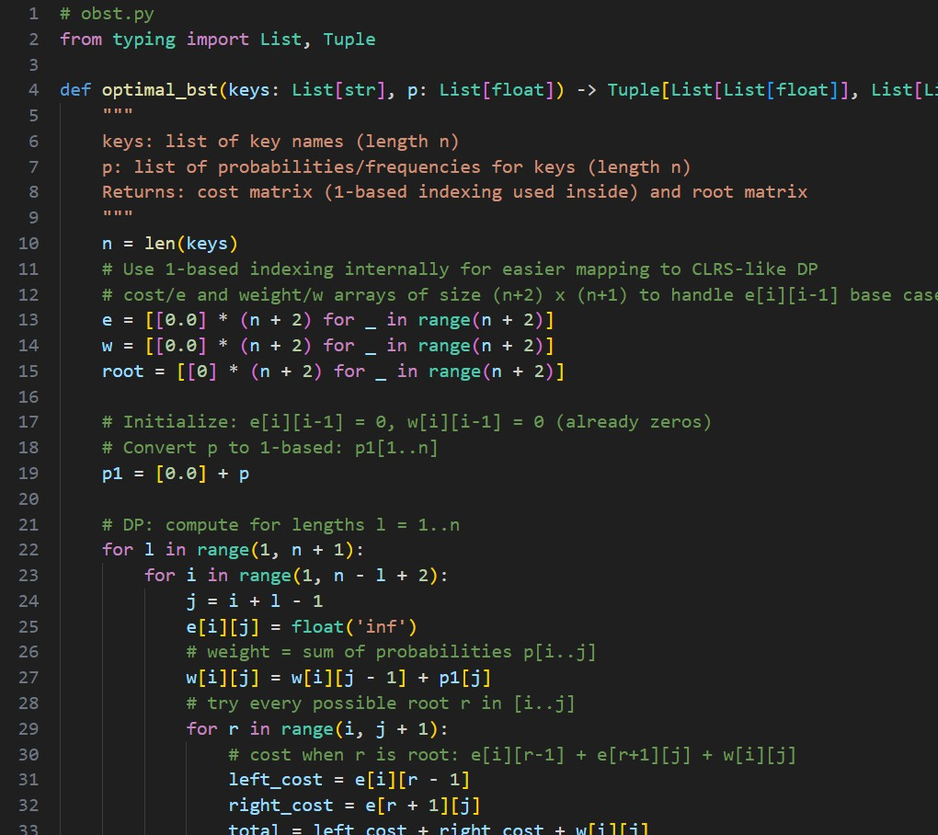

Input: Keys = {A,B,C,D}, Freq = {0.1, 0.2, 0.3, 0.4}

Output: Cost = 1.7

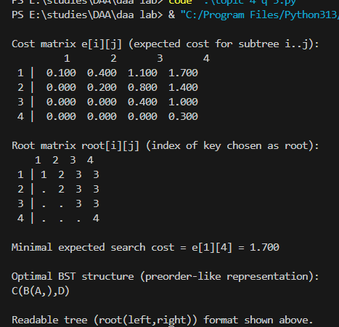

Result: OBST constructed with minimal expected cost.

